M1 Lesson 5: The Johari Window
Core Competencies:

- Communication | - Thinking | - Personal & Social

Big Ideas:

- Reflecting on our preferences and skills helps us identify the steps we need to take to achieve our career goals
Curricular Competencies:

- Use self-assessment and reflection to develop awareness of their strengths, preferences and skills
- Recognize the impact of personal public identity in the world of work
The Johari Window is a great concept for students to understand their relationship with themselves and with others, and fulfills the following curricular competencies:
Lesson:
The following are the four quadrants of a Johari Window (as taken from https://en.wikipedia.org/wiki/Johari_window)
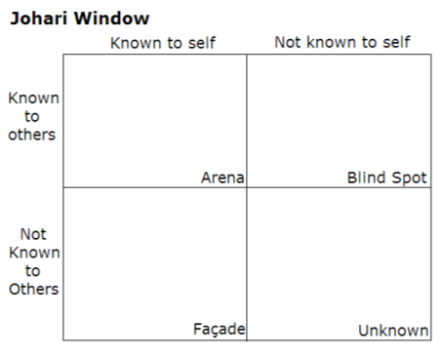
Open, or Arena:
● Adjectives that both the student and friends/family go in this cell (or quadrant) of the grid. These are traits that both the student and their friends/family perceive
Hidden, or Façade:
● Adjectives selected by the student, but not by any of their friends/family, go in this quadrant. These are things the friends/family are either unaware of (such as self conscious), or that are perhaps untrue however the student feels it is true.
Blind Spot:
● Adjectives not selected by student, but only by their friends/family go here. These represent what others perceive but the student does not.
Unknown:
● Adjectives that neither student nor their friends or family go here. They represent the student’s behaviors or motives that no one participating recognizes—either because they do not apply or because they are ignorant of these traits. It is the unconscious part that neither themselves nor their friends and family see. I usually instruct students to start this with “I wonder…”, or use the adjectives that they are unsure of, as they haven’t experienced circumstances to demonstrate those personality traits.
Format
I normally teach the Johari Window through the movie “Beauty and the Beast”. If time does not allow for watching the movie as a class, I would have the students work in groups (try to group students who have seen the movie with students who have not) to complete a Johari Window for Beast. (Assignment attached)
Students will be developing their own Johari Window.
ADJECTIVES THAT CAN BE USED AS DESCRIPTORS IN A JOHARI WINDOW:
able | energetic | loving | searching
accepting | extroverted | mature | self-assertive
adaptable | friendly | modest | self-conscious
bold | giving | nervous | sensible
brave | happy | observant | sentimental
calm | helpful | organized | shy
caring | idealistic | patient | silly
cheerful | independent | powerful | spontaneous
clever | ingenious | proud | sympathetic
complex | intelligent | quiet | tense
confident | introverted | reflective | trustworthy
dependable | kind | relaxed | warm
dignified | knowledgeable | religious | wise
empathetic | logical | responsive | witty
*See attachment for the Johari Window Assignment for Beauty and the Beast. Students will make a Johari Window for themselves in an assignment in Module 2*

