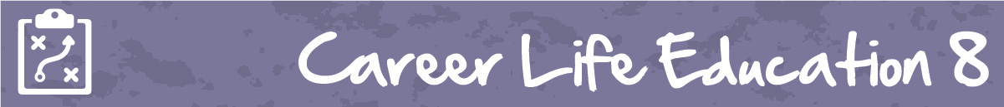

M2 Lesson 1: The Future of Work
Core Competencies:

- Communication | - Thinking | - Personal & Social

Big Ideas:

- The value of work in our lives, communities, and society can be viewed from different perspectives
Curricular Competencies:

- Use self-assessment and reflection to develop awareness of their strengths, preferences and skills
- Apply a variety of research skills to expand their knowledge of diverse career possibilities and understand career clusters
- Recognize the influence of curriculum choices and co-curricular activities on career paths
Lesson:
The Future of Work
Thinking about how careers will look in the future compared to how they are today is an important aspect of looking ahead with career planning, and in figuring out which jobs will be needed in your community in the future. In this lesson, you will research the basic responsibilities of a career of or your choice and compare it to how you think this position will look in the future.
Watch Anthony Goldbloom’s TEDTalk “The jobs we’ll lose to machines, and the ones we won’t”
Video: https://www.youtube.com/watch?v=gWmRkYsLzB4
Discuss with a classmate or family member how careers have changed over time and how you feel they will continue to change in the future. Are there any commonalities between careers that have become obsolete and ones that are predicted to be popular in the future?
Assignment
Part 1
Choose a career from the document attachment and search for it in the Occupations page on myBlueprint. Read through all the information on this career then add the occupation to your Career Education 8 portfolio.
Part 2
Complete the Venn diagram attached with the skills, qualifications, duties, and work environment for the career you chose, and how you think it will change in the future.
Assessment
