M2 Lesson 1: Perspectives on the Value of Work
Core Competencies:
- Communication | - Thinking | - Personal & Social

Big Ideas:
- The value of work in our lives, communities and society can be viewed from diverse perspectives.
Curricular Competencies:
- Use self-assessment and reflection to develop awareness of their strengths, preferences and skills
- Apply a variety of research skills to expand their knowledge of diverse career possibilities and understand career clusters

In this lesson, students will have the opportunity to explore potential careers that they have been matched to depending on their myBlueprint results, answer more questions in order to get better results, and then review and reflect on the outcomes of the results.

For students:
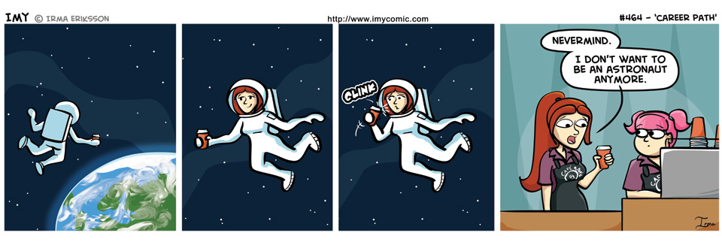
Similar to the comic above, sometimes the smallest change requires us to adapt and be flexible with our career path. Tim Urban, writer of the blog www.waitbutwhy.com offers his advice on why it is so important to pick a career that actually fits you:
Career-path-carving is definitely one of those really really deeply important things. Let’s spell out the obvious reasons why:
Time. For most of us, a career (including ancillary career time, like time spent commuting and thinking about your work) will eat up somewhere between 50,000 and 150,000 hours. At the moment, a long human life runs at about 750,000 hours. When you subtract childhood (~175,000 hours) and the portion of your adult life you’ll spend sleeping, eating, exercising, and otherwise taking care of the human pet you live in, along with errands and general life upkeep (~325,000 hours), you’re left with 250,000 “meaningful adult hours.” So a typical career will take up somewhere between 20% and 60% of your meaningful adult time.
Quality of Life. Your career has a major effect on all the non-career hours as well. For those of us not already wealthy through past earnings, marriage, or inheritance, a career doubles as our means of support. The particulars of your career also often play a big role in determining where you live, how flexible your life is, the kinds of things you’re able to do in your free time, and sometimes even in who you end up marrying.
Impact. On top of your career being the way you spend much of your time and the means of support for the rest of your time, your career triples as your primary mode of impact-making. Every human life touches thousands of other lives in thousands of different ways, and all of those lives you alter then go on to touch thousands of lives of their own. All lives make a large impact on the world and on the future—but the kind of impact you end up making is largely within your control, depending on the values you live by and the places you direct your energy. Whatever shape your career path ends up taking, the world will be altered by it.
Identity. In our childhoods, people ask us about our career plans by asking us what we want to be when we grow up. When we grow up, we tell people about our careers by telling them what we are. We don’t say, “I practice law”—we say, “I am a lawyer.” This is probably an unhealthy way to think about careers, but the way many societies are right now, a person’s career quadruples as the person’s primary identity. Which is kind of a big thing.
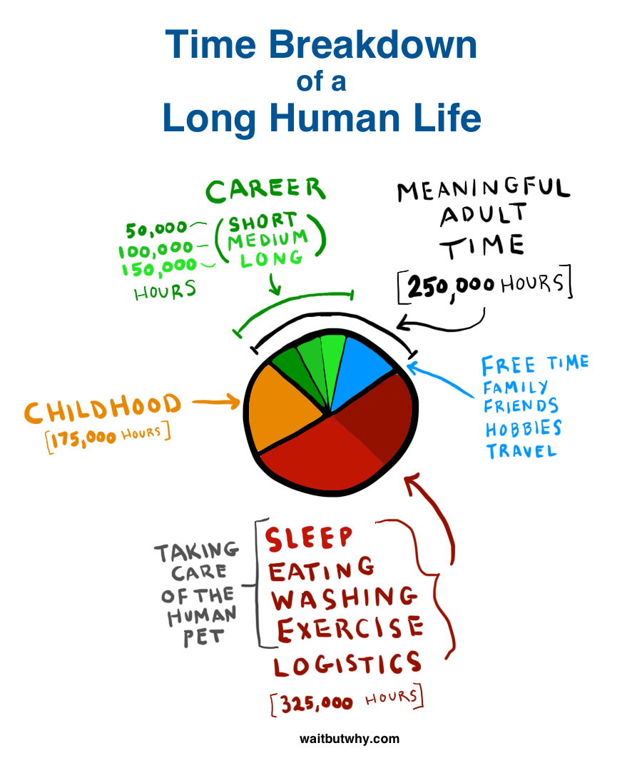

Assignment:
In the last assignment, you completed a number of surveys in order for myBlueprint to get a better idea of your own personality, interests, motivators, knowledge and learning style to get a sense of potential careers that may interest you. In this assignment, you will further explore some of these career options using myBlueprint.
Instructions:
- Log into your myBlueprint portfolio and click on the "Who Am I" sidebar. Then click on "Match Results" like in the image below and your Occupation Matches should appear underneath.
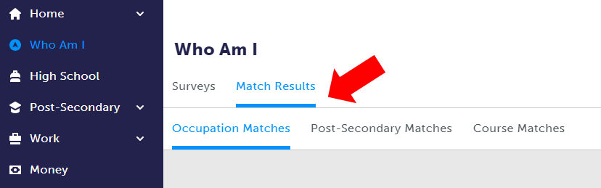
- Now make a list of the careers listed in the order presented before you go to Step 3. It's important to do this now, as the order will likely change as you continue this assignment.
- Choose "Get Started" button next to the top career listed in your Occupation Match. When you select "Get Started", you will be asked an additional ten questions relating to that specific profession, and a percentage match for that career. Answer the questions for the next four career options as well.
- Finally, answer the following questions about the career information presented to you in myBlueprint:
  - List the careers presented to you before you answered the additional questions. How do they compare to the order that is by percentage match. Did they change a great deal, or very little? Why?
  - What are the commonalities or differences between the careers presented to you in your top matches? Do the careers have similar duties or responsibilities? Do they use similar or different skills?
  - How useful do you feel career surveys are in determining a career path? If you had a friend who was having a tough time deciding on a career path, would you recommend they take the career compatibility test? What additional resources do you think they could use in your community?
Extension:
If students want an extension activity looking at the time spent on different activities during the day, the "What's on your plate?" activity is an interesting assignment or in-class activity to see how the structure of their day could translate into the structure of their careers or lives.
Assessment:
(see next page)
