M2 Lesson 4: The Value of Volunteering
Core Competencies:
- Communication | - Thinking | - Personal & Social

Big Ideas:
- The value of work in our lives, communities and society can be viewed from diverse perspectives.
Curricular Competencies:
- Use self-assessment and reflection to develop awareness of their strengths, preferences and skills
- Question self and others about how individual purposes and passions can support the needs of the local and global community when considering career choices
- Explore volunteer and other new learning experiences that stimulate entrepreneurial and innovative thinking

In this lesson, students will learn about the many benefits of volunteering and how they relate to community connectedness. Students will have a chance to explore different volunteerism programs in their community, grants that are available to support community projects, and develop a volunteer project that meets needs in their community.

For students:
A lot of the time, students will tell me "I can't get a job...I don't have any experience!", and it seems that you can't get the job without the experience, or the experience without the job. Being in Grade 9 is a challenging time; a lot of students want to start gaining employability skills, but aren't sure where to start. In this lesson, you will recognize the value of volunteering; not only does it directly benefit your community and those around you, but it adds to your experience and skills as well! Let's get started!
As a class, brainstorm the ways that volunteerism benefits both the volunteer and the community. T-charts would be helpful with students working in small groups.
Then review:
It's important to really take note of all the ways that volunteering can help you on your career path:
Volunteering gives you experience.
Most employers want workers who have at least some workplace experience. Volunteer experience shows employers that you can manage your time and complete your tasks. It also shows that you can get along with others and make a commitment. Your volunteer record can show an employer that you have the attitude and skills they are looking for in a potential employee.
Volunteering helps you develop skills.
Volunteering gives you a chance to build on skills you already have and learn new ones. For example, as a volunteer you might be able to use your second language or public speaking skills. You could also learn a new computer program or develop new customer service skills.
Be realistic about your current skill level when you apply to volunteer. An organization may need people whose skill level is more advanced than yours in the position you want. Seek opportunities to develop your skills so that you can later qualify for a more challenging position.
Volunteering expands your network.
Your network is all the people you know and all the people they know. Volunteering gives you the chance to meet new people and expand your network. Keep a list of the contacts you make while volunteering. These include staff, board members, clients, other volunteers and suppliers. You never know who might help you and how.
Volunteering lets you check out an occupation or industry.
When you’re considering choosing a career direction, volunteering gives you a chance to explore different occupations and industry sectors. You get to know the people, challenges and rewards involved. You also gain a better understanding of the roles and jobs available. For example, as a hospital volunteer you’re exposed to a wide range of health care workers, from front-line nursing and doctors to program administrators.
Volunteer experience in a specific field or industry can make your resumé or application stand out. This holds true when you’re competing for a job or applying to a post-secondary program in that field. For example, volunteer experience at an animal shelter might increase your chances of being admitted to an animal health technology program.
Volunteering builds your confidence.
Maintaining your confidence is especially important if you’re new to the working world! It also helps when you are discouraged in your search for a new job. Volunteering can help you feel active, useful and productive.
Volunteering helps you get to know yourself.
Knowing your skills, accomplishments, interests and values is the foundation of career success. Volunteer experience can be a good way to learn more about yourself and your potential to grow and develop. It also gives you a chance to find out how other people view you and your strengths.
Volunteering is a win-win situation. By helping others, you have the opportunity to boost not only your career but also your own well-being. When you volunteer in a role that’s right for you, everybody comes out ahead.
Adapted from: https://alis.alberta.ca/look-for-work/work-options/6-ways-volunteering-can-boost-your-career/
Class Research:
Did you know that there is grant money available to help you better serve your community? What is a grant? A grant is sum of money given by an organization, especially a government, for a particular purpose, that does not need to be paid back!
Most communities will have a grant program for non-profit organizations, and it's easy to apply. Here are some links to grant programs in different cities in our province:

https://cvcfoundation.org/grants/available-grants/community-enrichment-grants/

https://www.burnaby.ca/Things-To-Do/Be-Involved/Grants/Festivals-Burnaby.html (Links to an external site.)

http://www.tofino.ca/arts-amp-culture-grants

https://www.kamloops.ca/our-community/grants-funding
With a partner or on your own, take some time to research community grant opportunities in your city. Share the results of your research with your classmates, using these guiding questions:
- Are grants available in your community?
- What are the requirements of applying for grants in your community?
- What types of programs and initiatives can the grants be used for?
- What do you feel is a need in your community that can be helped with a program funded by a grant?
- In your opinion, what can be done to encourage youth to apply for grants in order to create change in their community?
Assignment:
Something that we should all know about is the Canada Service Corps program. Developed by the Government of Canada, the Canada Service Corps program gives youth the opportunity to serve their communities and their country in order to build a better Canada. The government will give you a grant to help turn your service idea into a reality!
In this assignment, you will read and complete the adapted Rising Youth Take Action Guide. By completing the guide, you will think about different issues in your community, skills you have to help those issues, use design thinking to think of radical ways to tackle the problems, and build a template for project design. Don't worry if you don't have an idea right now - this assignment is just a way for you to start thinking about needs in your community and how they can be tackled!
You are welcome to download the guide or use Acrobat to change into a fillable pdf and upload into both your myBlueprint Grade 9 portfolio as well as submitting it to your teacher.
Note: The Rising Youth Take Action Guide link on the portal has had some pages removed to reduce the size of the document. For more ideas of project ideas and information to assist you with completing the sections, take a look at the full document: http://risingyouth.ca/files/Rising-Youth_Take-Action-Guide.pdf.
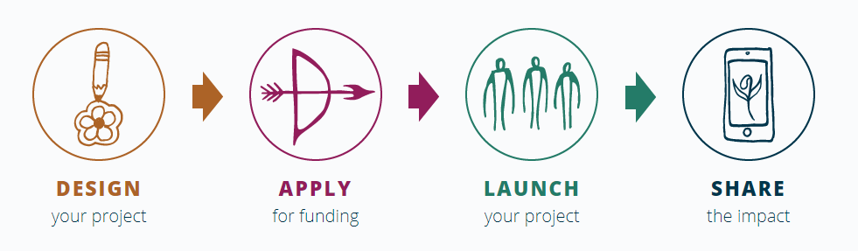
Assessment:
(see next page)
