M3 Lesson 2: Setting Goals
Core Competencies:

- Communication | - Thinking | - Personal & Social

Big Ideas:

- Achieving our learning goals requires effort and perseverance
Curricular Competencies:
- Use self-assessment and reflection to develop awareness of their strengths, preferences and skills
- Set and achieve realistic learning goals with perseverance and resilience
Lesson:
Setting Goals
Let's communicate what you would like to do in the future...
"Which road should I take?" asked Alice. "Where do you want to go?" inquired the Cheshire Cat in Lewis Carroll's Alice in Wonderland. Alice replied, "I don't rightly know." His response was, "If you don't know where you want to go, then either road will get you there."
I'll let you decide the lesson of this tale!
You have looked at yourself very closely and have recognized your particular talents and skills. You have tried some online personality tests and read what the results say about you.
Now, it is time to move on and begin working toward your future. whatever that may be.
Being able to set goals is an important thing to learn. Here's a story about goal setting:
A poll was taken in the 1973 graduating class at Yale University to see how many of the students had set goals. About two thirds of the students had not set any goals and didn't know where they were headed in their lives. Another 30% said they had goals but had not written them down. Only 3% of the students had written down their goals.
Twenty years later they were all contacted. Researchers found that the 3% who had written down their goals had gathered more wealth than the other 97% all combined.
The study goes on to say that gathering wealth is not the most important thing in life - but in this case it was used as a measuring device. (TeenOutReach.com)
What does this story tell you about the importance of writing down goals?
The Conference Board of Canada's Employability Skills 2000+ (Links to an external site.)Links to an external site. divides skills for success in the workplace into: Academic Skills, Personal Management Skills, and Teamwork Skills. What does this mean to you? It means that is important to set goals in your school work, continue to work at setting goals and achieving them, and be able to work with other people in achieving goals.
You probably have already set and achieved many academic, personal management and teamwork goals in your life without even knowing that they were goals.
- Finishing elementary school or your most recent grade (academic)
- Learning how to play baseball or soccer (teamwork)
- Practicing a new skill regularly, such as break-dancing, throwing the Frisbee or practicing the piano (personal management)
- Taking turns with a brother or sister to walk the dog (teamwork)
- Saving money for something special that you would like to buy, such as a bike (personal management)
- Eating a balanced meal, and not skipping meals (personal management)
- Creating a timetable listing when you have assignments due (academic skills)
- Receiving your babysitting or first aid certificate (academic skills)
- Giving your friend a compliment on their success on a test (teamwork skills)
Remember - a goal is just a wish or a dream until it is:
- Written in present-tense terms (This week, I am going to...)
- Is concrete (I will work hard at...)
- Is measurable (I will have shown that I can...)
- Has a time limit (By next week, I will have...)
Getting It Together
Setting Goals
There comes a time when you start dreaming and thinking about what it is you want to do with 'the rest of your life'. You think you may know what you want to do but you are not quite sure of how to get there and realize this goal. It's not enough to just have a dream; you have to decide how you're going to make it a reality. This is where goal setting comes in.
For example, if you would like to purchase a motorcycle, you could get a job now (babysitting, mowing lawns, doing odd jobs) and begin saving money each month. Then, when you are sixteen and can legally drive, you will have the money to actually go out and buy a motorcycle.
Setting and working toward these kinds of goals are what will eventually lead you to accomplishing your dreams.
Not exactly sure what your goals are yet?
That's OK.
It takes time to figure out where you want to go and what you want to do in life.
Assignment – Part 1
1. Autobiography of Me: yesterday, today and tomorrow:
The intent of this assignment is for you to have a chance to summarize all the information you learned about yourself and what goals / plans / hopes you might have for your future. An autobiography is the story of you. For this assignment you are to write about yourself as a student / learner and the goals and dreams you have for your future. Your story should cover your past, your present and your future. Your future section should describe how you see yourself and your life 15 years from now. It should also include information you learned about yourself in all those self tests you worked through in module 1. If you like you can quote relevant parts of these self test summaries. Be creative - you can include other ways of describing yourself (pictures, movies, sound clips. etc).
To start you thinking along these lines, let's look at things that you love to do already, things you don't enjoy doing at all, things you want to learn and things you think you're good at. A pattern should begin to emerge which will help point you in the direction of your goals.
This assignment should be about 500 words in length.
As well...
2. Now that you have thought about your goals in writing your autobiography, you are going to add five goals to your myBlueprint portfolio:
- Visit www.myBlueprint.ca, and enter your email and password to log in.
- In the left-hand navigation menu, click Home and select Goals.
- Select + Add Goal to create a new Goal for this activity, defining the goal and its timeline.
- Add at least three tasks you need to do in order to accomplish your goal.
- Repeat steps 3 and 4 for four additional goals.
Throughout the course, you should revisit your goals in myBlueprint often and remind yourself of the tasks you need to accomplish each goal. This is a great way to work on your accountability and responsibility!
Take a screenshot of this part of the assignment.
Assignment – Part 2
Achievement of our goals is closely linked to our own personal habits: what our regular tendency or practice something is and are things that are especially hard to give up. Our habits can work for or against achieving our goals, so let's take a critical look at our habits and what we need to work on!
Revisit the five goals that you added to your myBlueprint portfolio. For each goal list two habits that you would like to improve on to help you reach your goal. For example, if my goal were to achieve a mark of at least 90% in Career Life Education 8, two habits I would like to work on are making sure I get at least 8 hours of sleep per night, and ensuring that I spend at least an hour each day on my class assignments. I would then decide what habits I need to change in the short and long term to ensure that this habit is helping me work positively towards my goals.
Being aware of your habits is a great way to think about the core competency of Personal Awareness and Responsibility.
Copy and paste the table below or make your own to complete and submit your assignment.
Goal #1:
Habit | Short -Term:  What I can do in the short term to improve this habit: | Long - Term:  What I can do in the long term to improve this habit:
#1
#2
Goal #2:
Habit | Short -Term:  What I can do in the short term to improve this habit: | Long - Term:  What I can do in the long term to improve this habit:
#1
#2
Goal #3:
Habit | Short -Term:  What I can do in the short term to improve this habit: | Long - Term:  What I can do in the long term to improve this habit:
#1
#2

Goal #4:
Habit | Short -Term:  What I can do in the short term to improve this habit: | Long - Term:  What I can do in the long term to improve this habit:
#1
#2
Goal #5:
Habit | Short -Term:  What I can do in the short term to improve this habit: | Long - Term:  What I can do in the long term to improve this habit:
#1
#2
Assessment – Part 1
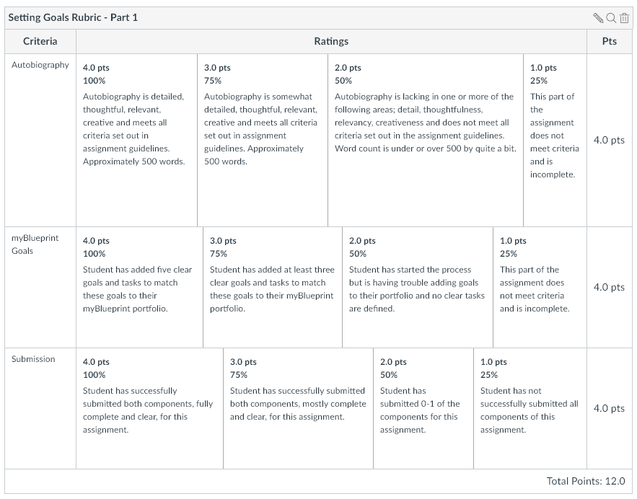
Assessment – Part 2
