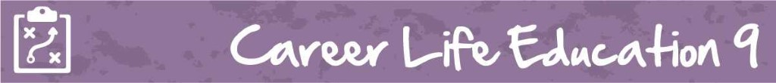
M3 Lesson 4: Thinking Ahead for a Graduation Plan
Core Competencies:
- Communication | - Thinking | - Personal & Social

Big Ideas:
- Achieving our learning goals requires effort and perseverance.
Curricular Competencies:
- Recognize the influence of curriculum choices and co-curricular activities on career paths
- Apply a variety of research skills to expand their knowledge of diverse career possibilities and understand career clusters
- Set and achieve realistic learning goals with perseverance and resilience

In this lesson, students will learn about the newly designed curriculum and how the graduation requirements have changed to now include Career Life Education, Career Life Connections, their Capstone Project, and numeracy and literacy assessments. Using the tools in myBlueprint, students will design a graduation plan for receiving a Dogwood diploma, understanding the need to remain flexible with their plan over the next few years.
For students:
Like many people, you're probably always looking back, wondering where the time has gone! As you reach the mid-point of this course, this lesson and assignment will help you think about your future and the choices you have to make as you enter Grade 10, as we all know how quickly time flies. Depending on your school, you may be getting close to the time where you need to choose your courses for Grade 10, an important year as you will be entering the Graduation Program!
You are entering your Graduation Program years at a really exciting time! The Government of British Columbia has recently changed the Graduation Requirements for British Columbia, giving you a lot more choice and freedom of what you want to learn in your schooling. The focus on the new graduation requirements is that they are learner-centered and offer flexible learning. Students have more personalized options and are able to take more personal responsibility for learning, and teachers have greater flexibility in creating learning environments that are relevant, engaging and novel. You have some great opportunities ahead of you!
Some of the changes that have been made are:
- Curriculum has been redesigned to be more learner-focused and flexible, with a focus on core competencies, big ideas and learning standards; Indigenous culture and perspectives have been integrated into all curriculum.
- New Course Structures such as this course - Career Education! Other examples include the Capstone Project you will present in Grade 12, making designed courses accessible to all students, and combining Health Education to Physical Education
- There are now two new provincial graduation assessments – a Literacy Assessment and a Numeracy Assessment that you will complete in Grade 12. The assessments are aligned with the redesigned curriculum.
Perhaps most importantly though, is the focus that you will have on your core competencies over the next three years, as the foundation of your Capstone Project will be on your growth in the three competencies. The competencies are an important part of your career life journey, as they are driven by global and technological changes. These competencies encompass the intellectual, personal and social skills you will need to develop for success in life beyond school and to become educated citizens.
The good news is that competencies will be embedded in all of the work you are already doing at school! They come into play when you are in any area of learning. Together, the literacy and numeracy foundations and core competencies contribute to the development of you as an educated citizen.
As a reminder, the competencies are:
• Communication – the set of abilities that you use to impart and exchange information, experiences and ideas, to explore the world around you, and to understand and effectively engage in the use of digital media
• Thinking – the knowledge, skills and processes you associate with intellectual development
• Personal and Social – the set of abilities that relate to your identity in the world, both as an individuals and as members of their community and society
Whew - we know that is a lot to think about! Don't worry though, we will introduce you to the graduation program and tools in myBlueprint to help with your graduation plan, and over the next three years you will continue to build on that plan to accomplish your post graduation goals!
Assignment:
The following assignment has two parts. In the first part, you will use the BC Ministry of Education Graduation Requirements website to start researching what is necessary to obtain a Dogwood Graduation Diploma in BC. In the second part of the assignment, you will use the course planning tool in myBlueprint to come up with one option to fulfill your graduation requirements. Let's get started!
Part 1:
Using the British Columbia Certificate of Graduation website, answer the following questions:
- For students graduating after June 30, 2018, how many credits will be required to graduate? Normally, how many credits do students receive for one course?
- How many credits must be from required courses, and how many credits must be received from elective courses?
- List the courses required for graduation in each of Grades 10, 11 and 12.
- Students need to complete two graduation assessments. Give a brief explanation of each (hint...use https://curriculum.gov.bc.ca/provincial-assessment/graduation for help!)
- What are the Career Education courses that are required for graduation?
Part 2:
In Part 2 of this assignment, you will use myBlueprint to explore one option for a course plan for Grades 10, 11 and 12. This initial plan will change as your interests and goals change between grades 10-12 but is a useful tool for visualizing one way to complete your graduation requirements.
Instructions:
1. Log into your myBlueprint account and click "High School" on the left-hand toolbar.
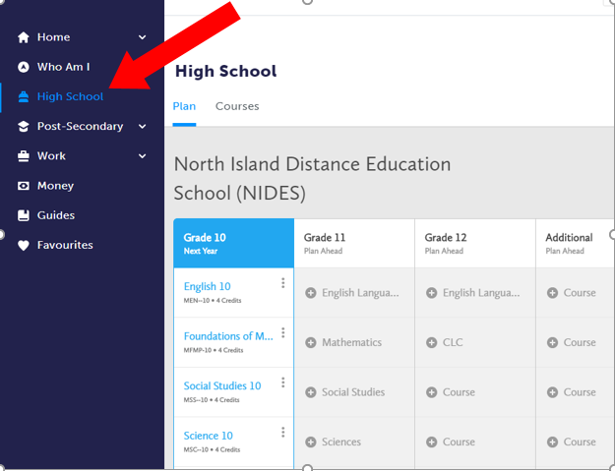
2. Using the graduation requirements you have identified in Part 1 of this assignment, use the High School plan tool to design one graduation option for Grades 10-12. Fill in the courses you could take in each grade to fulfill graduation requirements. In no way is this a commitment to these courses - we are just playing with options, and how to keep track of how those options change while still ensuring we will graduate!
Please ensure that you have the following courses in your graduation plan:
- A language arts (for example, English) course in each of Grades 10, 11 & 12
- CLE 10 and CLC 12
- P.E. 10
- Science 10 and a Science 11 or 12
- Socials 10 and a Socials 11 or 12
- a Math 10 and a Math 11 or 12
- an Arts Education or Applied Skills, Design and Technologies 10, 11 or 12
- at least 28 credits of electives
- at least 12 credits of Grade 12 courses, not including Language Arts 12
3. In a short journal entry of approximately 400 words, reflect on the graduation plan you outlined in Part 2 of your assignment. Use these guiding questions to help in your response:
- Planning for graduation brings out different feelings in all of us. Some of us are nervous, some anxious, some excited, and some of us would prefer to just put our head in the sand! Explain your feelings as you begin to plan for your graduation.
- How did you come to choose the courses you did in your Grade 10/11/12 plan? Use specific course examples in your reply.
- As we begin to plan out our path, it's important to realize that a lot of changes are going to come our way that will require us to be flexible with our plan. Give some examples of events that could mean a change in your plan, and how you would navigate those changes.

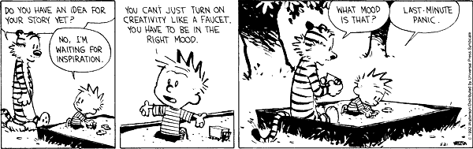
Assessment:
