s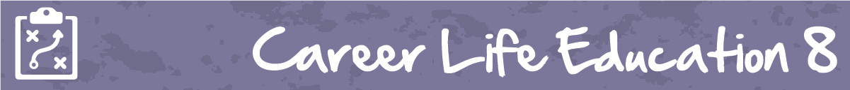

M5 Lesson 1: Overcoming Life’s Obstacles
Core Competencies:

- Communication | - Thinking | - Personal & Social

Big Ideas:

- Our career paths reflect the personal, community and educational choices we make
Curricular Competencies:
- Use self-assessment and reflection to develop awareness of their strengths, preferences and skills
- Set and achieve realistic learning goals with perseverance and resilience
- Apply decision making strategies to a life, work, or community problem and adjust the strategies to adapt to new situations
Lesson:
While they may not be very fun at the time you are going through them, obstacles and problems can actually help you grow and develop as a person, as well as teach you valuable life lessons.
Video: How Obstacles Can Help You Succeed:
https://www.youtube.com/watch?v=KubBVcUPWm0
Obstacles are just a part of everyday life, and it is important to learn strategies to overcome them and learn from them. The assignment for this lesson will show you how.
Assignment:
Download and complete the assignment document that looks at obstacles you have faced in your own life.
You can find the “Overcoming Life’s Obstacles” assignment as an attachment in the portal.
Assessment:
