s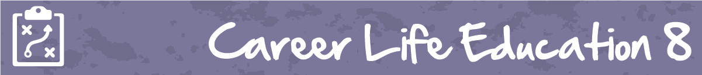

M6 Lesson 2: Building Blocks of Core Competencies
Core Competencies:

- Communication | - Thinking | - Personal & Social

Big Ideas:

- Our career paths reflect the personal, community and educational choices we make
Curricular Competencies:
- Question self and others about how individual purposes and passions can support the needs of the local and global community when considering career choices
- Set and achieve realistic learning goals with perseverance and resilience
Assignment:
In your final assignment (yay!), you will think about the hard work you have done here in Career Life Education, and how it relates to the development of your core competencies.
In the assignment below, you will be asked to reflect your growth in each of the three core competencies; communication, creative and critical thinking, and personal awareness and responsibility. Your assessment will be based on your ability to analyze the work you have done in relation to your competency growth, or ability to further grow this competency in the future.
CLE 8 Core Competencies Review Assignment can be found as an assignment in the portal.
Congratulations on all of your hard work!
Assessment:
(see next page)
