CLE 9 – Linking Career Possibilities to Demand
WorkBC has done a lot of the hard work for us by researching career possibilities and linking them to demand in our province and our region. In this assignment, you will research demanded careers in certain career clusters and based on education level, and compare these careers to those in demand in your region.

Use the site https://www.workbc.ca/Labour-Market-Industry/High-Demand-Occupations.aspx to fill out the following chart:

Occupations in British Columbia | Median Hourly Wage | Job Openings to 2028
- Top 5 High Demand Occupations in Management
(Education and Work Experience)
1.

2.

3.

4.

5.

- Top 5 High Demand that Require a Degree Program
1.

2.

3.

4.

5.

- Top 5 High Demand that Require a Diploma, Certificate or Apprenticeship
1.

2.

3.

4.

5.

- Top 5 High Demand that Require a High School Diploma
1.

2.

3.

4.

5.

- Top 5 High Demand Priority Health Occupations
1.

2.

3.

4.

5.

In Part 2 of this assignment, you will now look at which careers will be in demand in your region of the province.

Visit https://www.workbc.ca/Labour-Market-Industry/Regional-Profiles.aspx and click on your region:
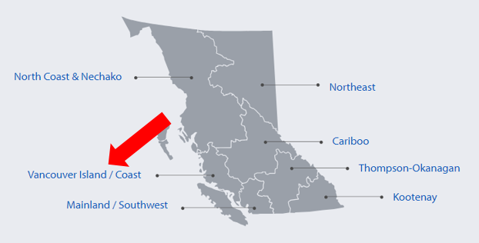
Once you have clicked on your region, click on “B.C. Labour Market Outlook (2017-2027) for this region:

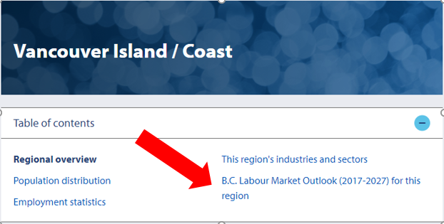

If you then scroll down to the bottom, you will see the Top Ten Occupations listed in terms of growth for your region. Copy the occupations here:

Your Region is:

Occupations in Your Region | Job Openings | Employment Growth
- Top 5 High Demand Occupations in Management
(Education and Work Experience)
1.

2.

3.

4.

5.

6.

7.

8.

9.

10.

