Module 5 Lesson 3 Assignment: Investigating the Part-Time Job Market
Not so long ago, when people were looking for a part-time job, they would typically look at job listings in the newspaper or go directly to the business and ask if they were hiring. Because companies can easily post jobs on the internet these days, online job sites are becoming more and more common, and are a great start to figuring out which businesses are hiring in your community!
Instructions:
1. Log into your myBlueprint account, and click "Job Search" under the heading "Work" on the left hand toolbar.
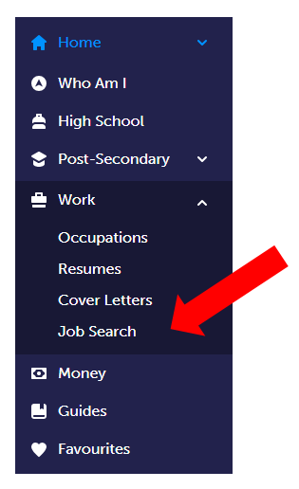
2. Under "Job Search" use the toolbar to search for jobs in your community. Try putting your town/city name in the "Where are you looking?" field and putting different options in the "What are you looking for?" field, such as part-time, restaurant, or retail.
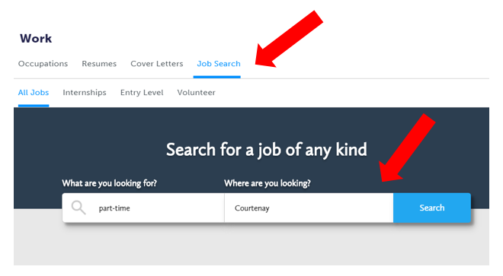
3. You will now be led to the results of your search. In the following assignment, you will now use those results in your assignment to describe five positions that you would be interested in applying for. Consider, based on the job qualifications and what would make you a good candidate for this job.
Part-Time Job Search Assignment
Upload your Job Search Assignment here.

