Module 5 Lesson 4 Assignment: Starting Your Resume
In today's assignment, you will start developing a resume of your own, using the Resume tool in myBlueprint. Understanding that you may not have experience to fill a resume, we are just laying the groundwork needed to continue and perfecting your resume in CLE 10 next year! This is a good opportunity though to see where you may want to gain more experience in the next couple of years to round out your resume sections.
Instructions:
1. Log into your myBlueprint account with your username and password.
2. On the left hand toolbar, choose "Resumes" under the "Work" heading.
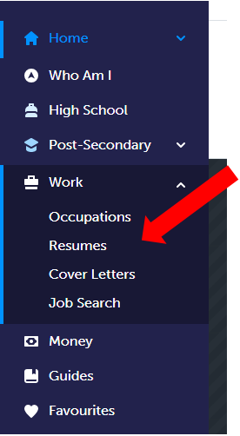
3. Click 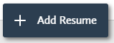 on the top right corner of your screen, and give your resume a title such as "Your Name Grade 9".
4. Take the time to work through the resume sections to the best of your ability. Remember to highlight your best skills and experiences, and use powerful verbs such as "organized" and "coordinated" instead of passive verbs such as "has" or "did".
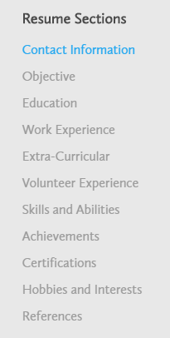
5. Experiment with the different features in myBlueprint such as layout and switching the order of you sections until you find one that you prefer.
6. Continually preview your resume by clicking 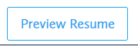at the bottom right hand side of your screen.
7. When your resume is finished, from the Preview Resume screen, click on 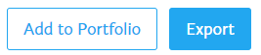. Add your resume to your Grade 9 portfolio and export it to a .pdf for submission.
Upload your Resume Assignment here

