Module 4 Lesson 5 Assignment: Staying Safe at Work
In the following workplace safety assignment, you will use the three steps of controlling, or eliminating a hazard in different workplace scenarios.
STEP ONE: Recognition - See it! (What is the unsafe act(s) or condition(s) that are happening?)
STEP TWO: Evaluation - Think it! (Why is this a hazardous situation? What could happen?)
STEP THREE: Control - Do it! (What should be done in order to make the workplace safer, or prevent an accident from happening?)
Download the Hazard Recognition Worksheet and use it to describe each of the six scenarios (three written, three pictures) in terms of what should be done to see it, think it and do it! For most scenarios, there are at least 5 items that can be used for each step in controlling or eliminating a hazard.
Scenario #1
Jamie walks into the art room at school to find Melissa's desk a mess. There is spilled glue drying in a puddle, and an exacto knife standing with its point up in the pencil holder. You notice in the corner that water has been spilt from a pottery water pot.
Scenario #2
In the cafeteria, Jose drops a glass bottle of ketchup and quickly goes to get a mop to clean up the ketchup and the broken glass, while Albert is cutting raw chicken and salad fixings on the same cutting board.
Scenario #3
John is in the drama room hanging stage lights using a straight ladder propped against the wall. He didn't get a chance to secure the safety wire before being interrupted by a classmate that needed help moving a heavy box.
Scenario #4
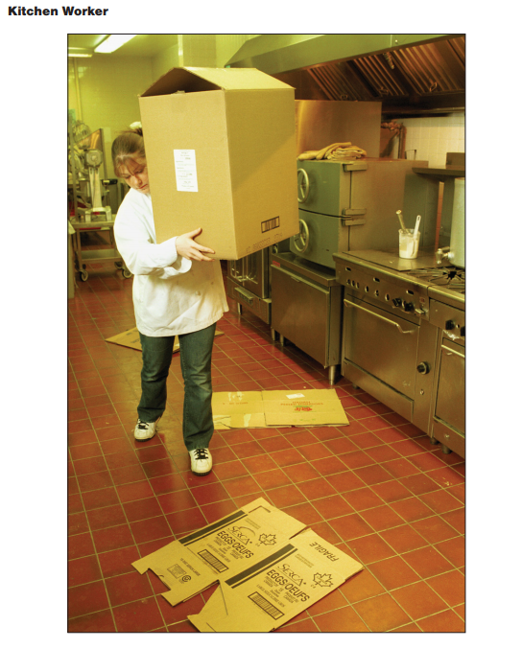
Scenario #5
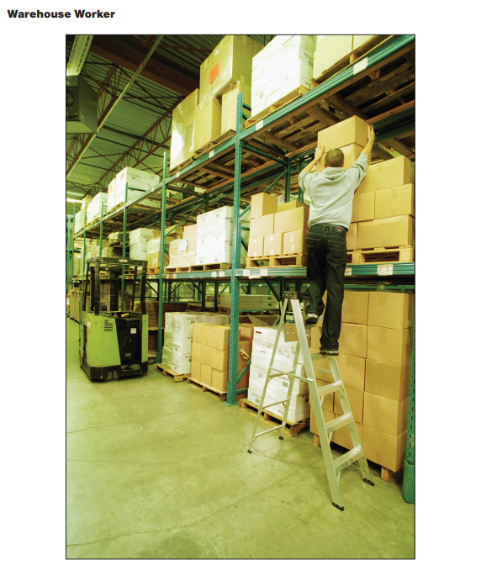
Scenario #6
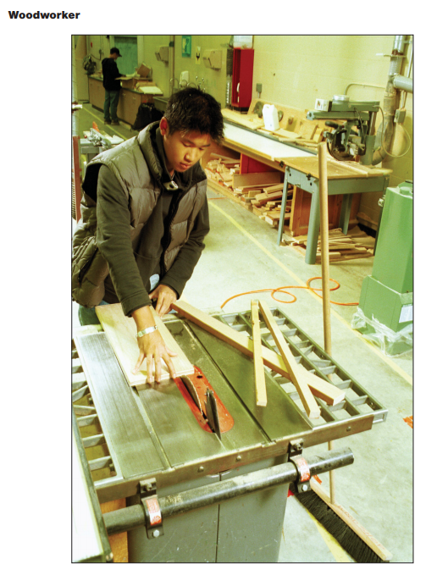
Resources from Worksafe BC - www.worksafebc.comLinks to an external site.
Upload your Hazard Recognition Assignment here

