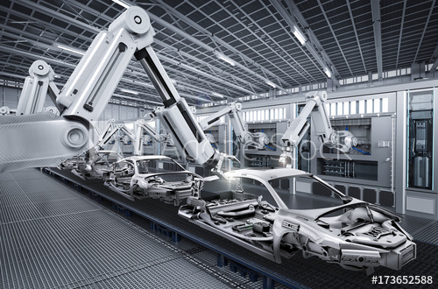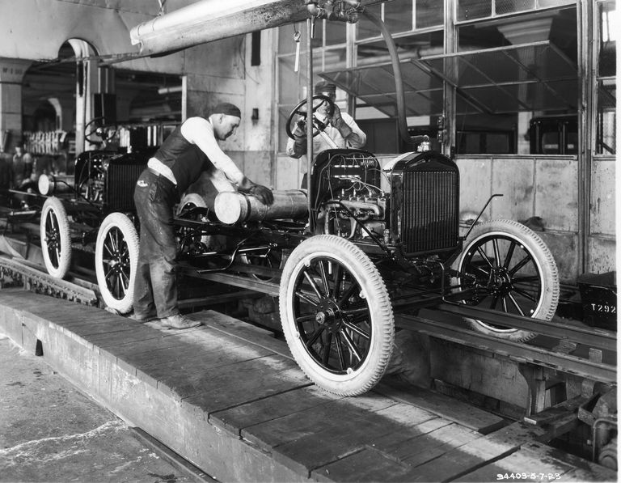

**The future**

of Work

Name: _________________

Career: _________________

Thinking about what careers look like now compared to what they may look like in the future is an important aspect of your own career planning. Using myBlueprint and www.workbc.ca, research the career you have chosen in terms of the skills and qualifications needed, the duties and the work environment, and try to think about how that could change in the next 20, 30 or 50 years!

The future...

Both

The past...