Module 2 Lesson 4 Assignment: Serving Your Community
Something that we should all know about is the Canada Service Corps program. Developed by the Government of Canada, the Canada Service Corps program gives youth the opportunity to serve their communities and their country in order to build a better Canada. The government will give you a grant to help turn your service idea into a reality!

Show video on https://www.canada.ca/en/employment-social-development/services/canada-service-corps.html
In this assignment, you will read and complete the adapted Rising Youth Take Action Guide. By completing the guide, you will think about different issues in your community, skills you have to help those issues, use design thinking to think of radical ways to tackle the problems, and build a template for project design. Don't worry if you don't have an idea right now - this assignment is just a way for you to start thinking about needs in your community and how they can be tackled!
You are welcome to download the guide or use Acrobat to change into a fillable pdf and upload into both your myBlueprint Grade 9 portfolio and submit below.
Note: The Rising Youth Take Action Guide above has had some pages removed to reduce the size of the document. For more ideas of project ideas and information to assist you with completing the sections, take a look at the full document: http://risingyouth.ca/files/Rising-Youth_Take-Action-Guide.pdf. (Links to an external site.)Links to an external site.
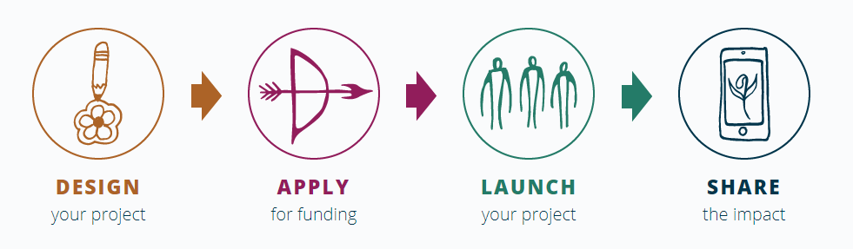
Upload your Service Opportunity assignment to your Grade 9 myBlueprint portfolio, as well as submitting it here.

