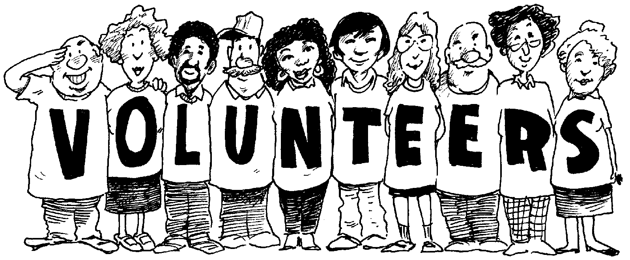
Connecting Volunteerism
to Your Community

There are so many opportunities to connect your own interests and skills to volunteer needs in your community, and even more reasons to be involved! Using the following websites, find five (5) current volunteer positions in your community and answer the following questions:
https://volunteerbc.bc.ca/ | https://www.govolunteer.ca/ | https://youth.volunteer.ca/

Volunteer Position #1: |  | Website Found:
Name of Organization | Brief Description of the Position | Commitment Needed | Skills / Interests/Passions you have that would Benefit the Organization

Volunteer Position #2: |  | Website Found:
Name of Organization | Brief Description of the Position | Commitment Needed | Skills / Interests/Passions you have that would Benefit the Organization
Volunteer Position #3: |  | Website Found:
Name of Organization | Brief Description of the Position | Commitment Needed | Skills / Interests/Passions you have that would Benefit the Organization

Volunteer Position #4: |  | Website Found:
Name of Organization | Brief Description of the Position | Commitment Needed | Skills / Interests/Passions you have that would Benefit the Organization

Volunteer Position #5: |  | Website Found:
Name of Organization | Brief Description of the Position | Commitment Needed | Skills / Interests/Passions you have that would Benefit the Organization
Which of these volunteer positions do you feel would be most interesting to you, and most beneficial to your community? Why?

